New Employee module

Intro to Bunge
See power point
Read The Bunge Blue book pdf
Safety at Bunge

Videos on Bunge Portal
On the Everything Bunge tab, underneath North America Departments and Functions select Agribusiness, then go to the Resources section. Watch the following videos in
Oilseed Value Chain Training
&
Life cycle of Corn, Soybean, Wheat Trianing

Bunge Locations
See BNA Maps power point

Common Terms
Cash price: Futures price plus basis = cash price, or the total price to a farmer
Futures price: Price for a given commodity at a given point in time, based off of the exchange markets below
Basis: The difference between cash price and futures price, used as a local determination of price based on supply and demand
Hedging: The process of mitigating risk using the futures market to offset either purchases or sales
Inverted vs carry market: Inverted market means the price today is more expensive than the price tomorrow, carry market means the price today is weaker than the price tomorrow
Long vs short: If you are long a commodity, you own or have to sell, if you are short, you sold or have to buy
S&D: Supply and Demand, Supply, as in production or total supply of a given crop, Demand, as in the total use of a crop
Spreads: The difference in prices between one month or another, most commonly used to demonstrate the price relationship between different months
CAKs: Another term for contracts
CBOT: Chicago Board of Trade, most commodities in the US traded based on these prices, soybeans, soybean meal, soybean oil, corn, wheat etc.
CME Group: Chicago Mercantile Exchange, owns the CBOT and other exchanges around the world,
ICE: Intercontinental Exchange, trades several products around the world, Canola seed futures are traded here
OVC: Oilseed Value Chain, term for the crush/refinery division

Futures Months
F - January
H - March
K – May
M – June
N – July
Q – August
U – September
V – October
X – November
Z - December

Weight conversions
See conversions excel spread sheet

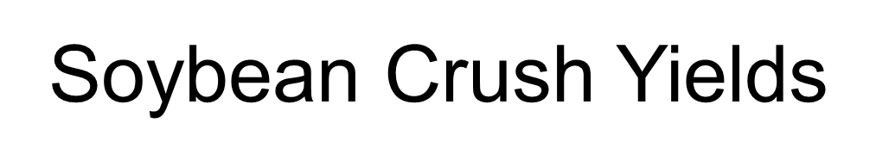
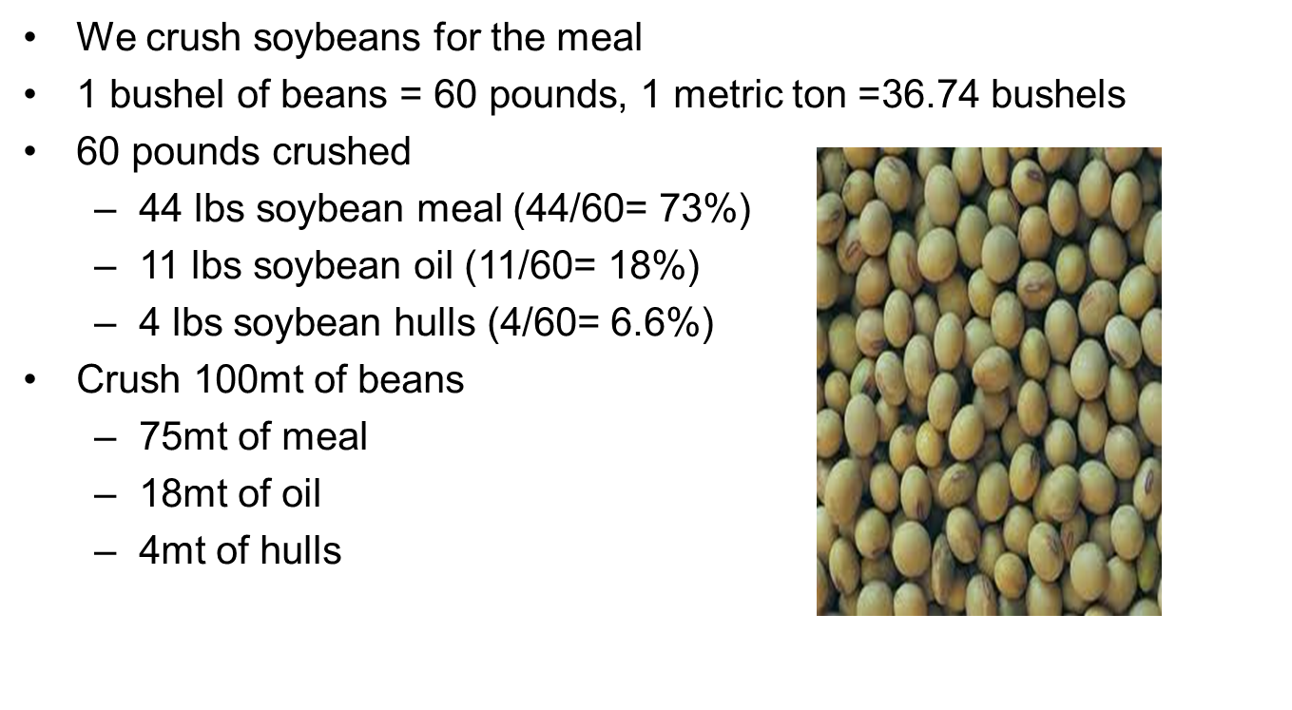

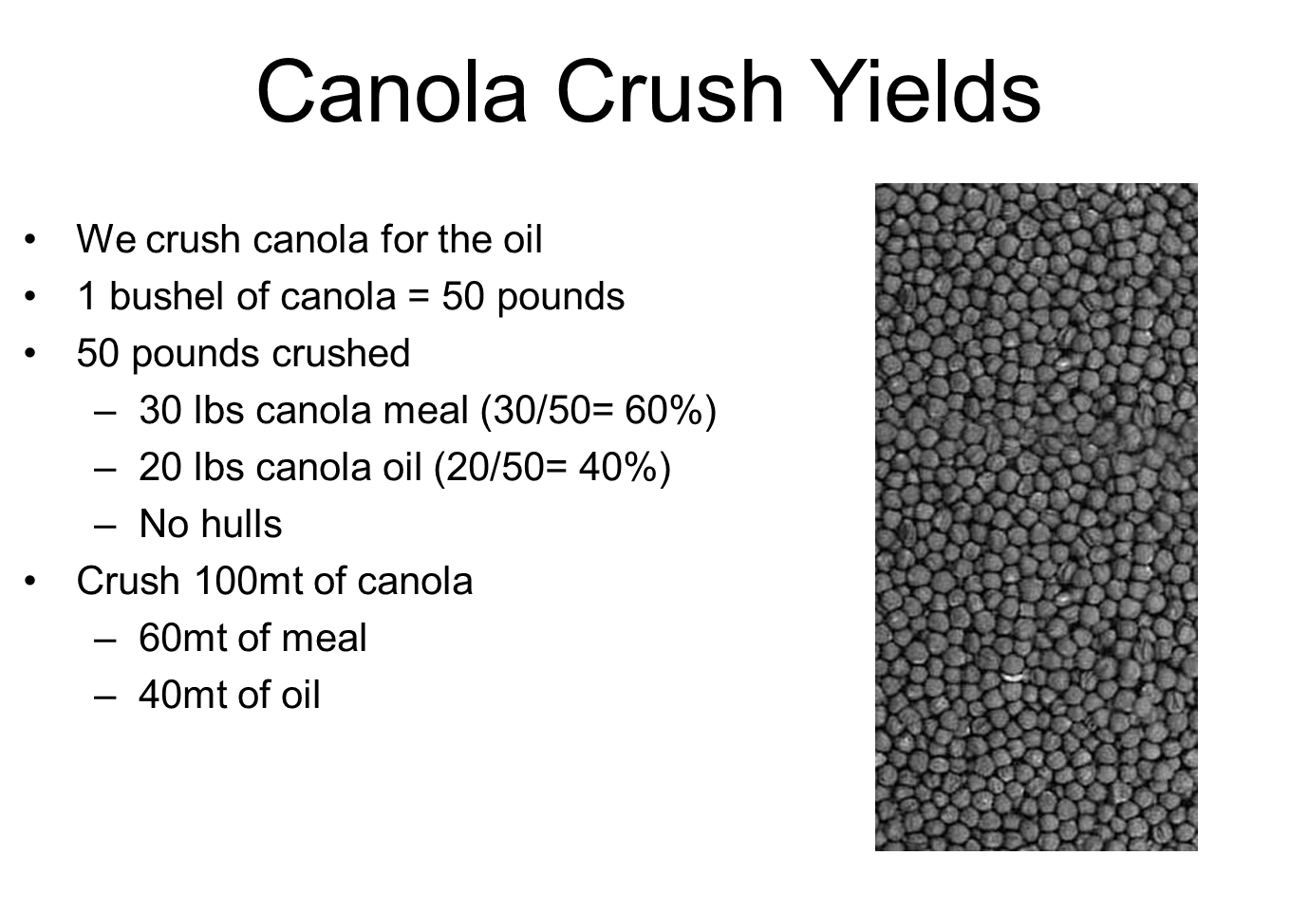

Industry groups
NOPA (North American Oilseed Processing Association): www.nopa.org
COPA (Canadian Oilseed Processing Association): www.copacanada.com
USDA (United States Department of Agriculture): www.usda.gov
WASDE (World Agriculture Supply and Demand Estimates): http://www.usda.gov/oce/commodity/wasde/
Canola Council of Canada: www.canolacouncil.org
Soy Canada: www.soycanada.ca
NGFA (National Grain and Feed Association): www.ngfa.org
NAEGA (North America Export Grain Association): www.naega.org

Accounting Terms

MTM: Mark to market, valuing assets to current market prices
Forecast: Weekly/monthly reports used to determine Profit and losses per business unit
Replacement Margin: used as a way to determine what our next ton crushed results in margin for a plant
Board Margin: way to hedge physical crush, as a user of commodities, we are inherently short soybeans/canola seed at all times and long the products of meal and oil, therefore to hedge our risks, we can create an artificial crush margin, by buying soybeans/seed, and selling meal and oil based upon yields.
LIM: Logical information machines, serves as a database of prices for market valuation for Bunge
SOX reports: Sarbances Oxley/Sarbox, originally created as a regulation to monitor corporations accouting practices/activity, for Bunge, generally used as generated reports out of SAP as a way to monitor contract activity.

Railways (see UP and North America Rail Maps powerpoint)
CN: Canadian National Railway
CP: Canadian Pacific
BNSF: Burlington Northern Santa Fe Railway
KCS: Kansas City Southern
UP: United Pacific

Shipping terms
Sshinc vs sshex: for vessel shipping, refers to Saturday, Sunday, holidays included, or for sshex, excluded.
Load/unload rate: Agreed upon rate at which product needs to be loaded/unloaded at port, anything above or below this number would result in demurrage, or dispatch
Demurrage vs dispatch: refers to the cost of holding equipment or loading/unloading outside of given load rate at plant/terminal, could be on trucks, rail or boat. Demurrage refers to a cost by loading slower than agreed load rate, dispatch refers to loading faster and in some cases results in a savings
Wwd: For vessel shipping, weather working days
Types of Vessels (lakers vs salties vs barges, and different sizes): Barges are flat bottomed boats, generally used in canals/rivers, smallest quantities of transport on water, typically used to ship product from upstream the Mississippi river downstream to the US Gulf.
Laker vessels are used within the Great Lakes, they do not exit the lakes. Typically 10-25k ton
Salty vessels are used for overseas shipments into the ocean (salt water – salty nickname), typically 10-20k ton
There are several different sizes of vessels, depending on where the terminal is located and body of water it must go through
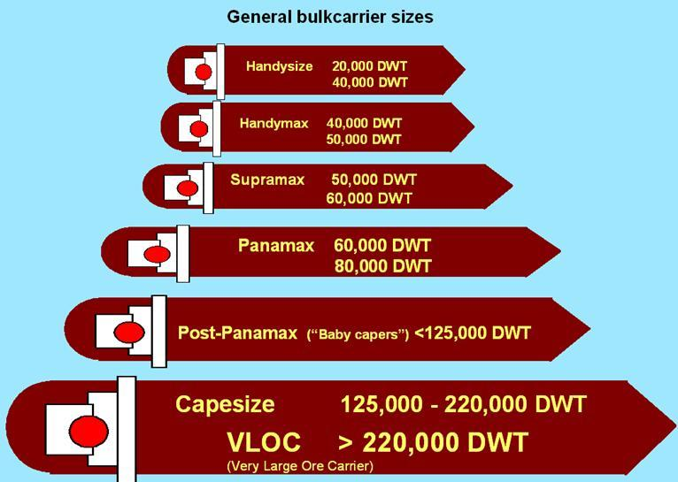

FOB vs CIF: FOB means Free on Board, sold at an origin ready to be picked up, CIF refers to cost, insurance and freight, meaning all costs are included in delivery to a selected point. CPT (carriage paid to) is basically a synonym of CIF used for any form of transport vs CIF which is usually used only for sea or inland water transport.

Major Ports for export
US
US Gulf
PNW
Canada
Vancouver
Thunder Bay
St Lawrence River

Bunge JVs
G3 Global Grain Group (www.g3.ca)
G3 Global Grain Group is a joint venture between Bunge Canada (Bunge) and SALIC Canada Ltd., a wholly owned subsidiary of Saudi Agricultural and Livestock Investment Company (SALIC), formed to invest in Canada’s agricultural grain industry by establishing a highly efficient coast–to-coast grain enterprise. G3 Canada Limited's assets include primary grain elevators and port terminals stretching from Leader, Saskatchewan to Québec City, Québec, a Great Lake grain transport vessel, and the largest private fleet of grain hopper cars in Canada. The vertical integration of these assets along the agricultural commodity chain forms the basis of a smarter path from farmers’ fields to global markets. G3 Canada Limited is a Canadian company and is headquartered in Winnipeg,
EGT (www.egtgrain.com)
EGT, LLC is a joint venture between Bunge North America, the North American operating arm of Bunge Limited, and ITOCHU International Inc., a U.S. subsidiary of Japanese trading company ITOCHU Corp. The terminal is among the leading facilities operating in the region, a status secured by its groundbreaking design that enables it to handle wheat, corn, soybeans, soybean meal, and DDGs through both barge and rail. Given these capabilities, EGT’s entry to the Pacific Northwest strengthens U.S. trade flows and sets a new standard for grain export.

Planting and Harvest by crop by Country.
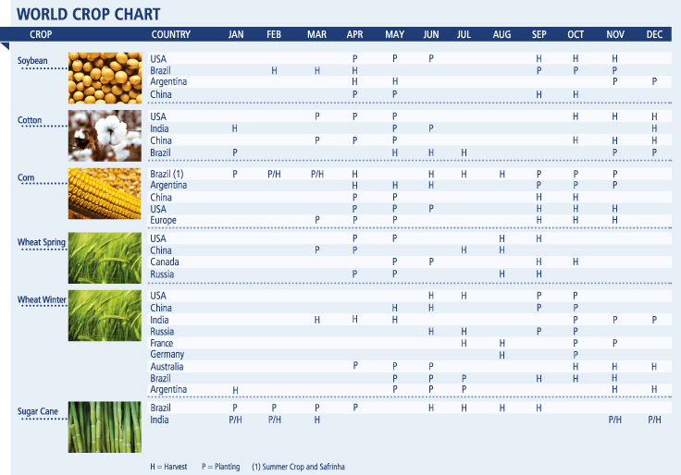

Bunge Internal systems
BP Open / Capgemini: BP Open is where all invoices are paid via portal to external parties, eg. Freight, software, office supplies, etc. Capgemini is our third party who handles Accounts Payables for BP Open.
E-time: System used for Time/Attendance, booking time off and entering hours if hourly employee
ADP Total Access: System used to find pay and tax statements within Canada, can sign up for electronic copies as well here
eRTD: electronic system used to hedge futures on the CBOT
Railtrac: internal system used to monitor rail cars whereabouts and can generate reports out of here
MDG: Master data governance, used to modify/create/edit/change all vendors/change
Bunge Services: Bunge website used for each location to post cash bids/offers, communicate to farmers (hours, special bulletins), access contract and shipping data, also mobile app. Information comes from GTM/SAP and is up to date, local admins can make adjustment to data for users to see.

