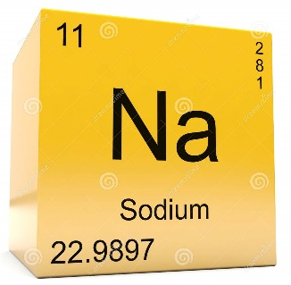
Date : ____________________________
Isotopes and Atomic Mass
Isotopes :

Scientist use mass number, the total number of ________________________ and _____________________ in the nucleus to distinguish between the different isotopes for a given element, for instance
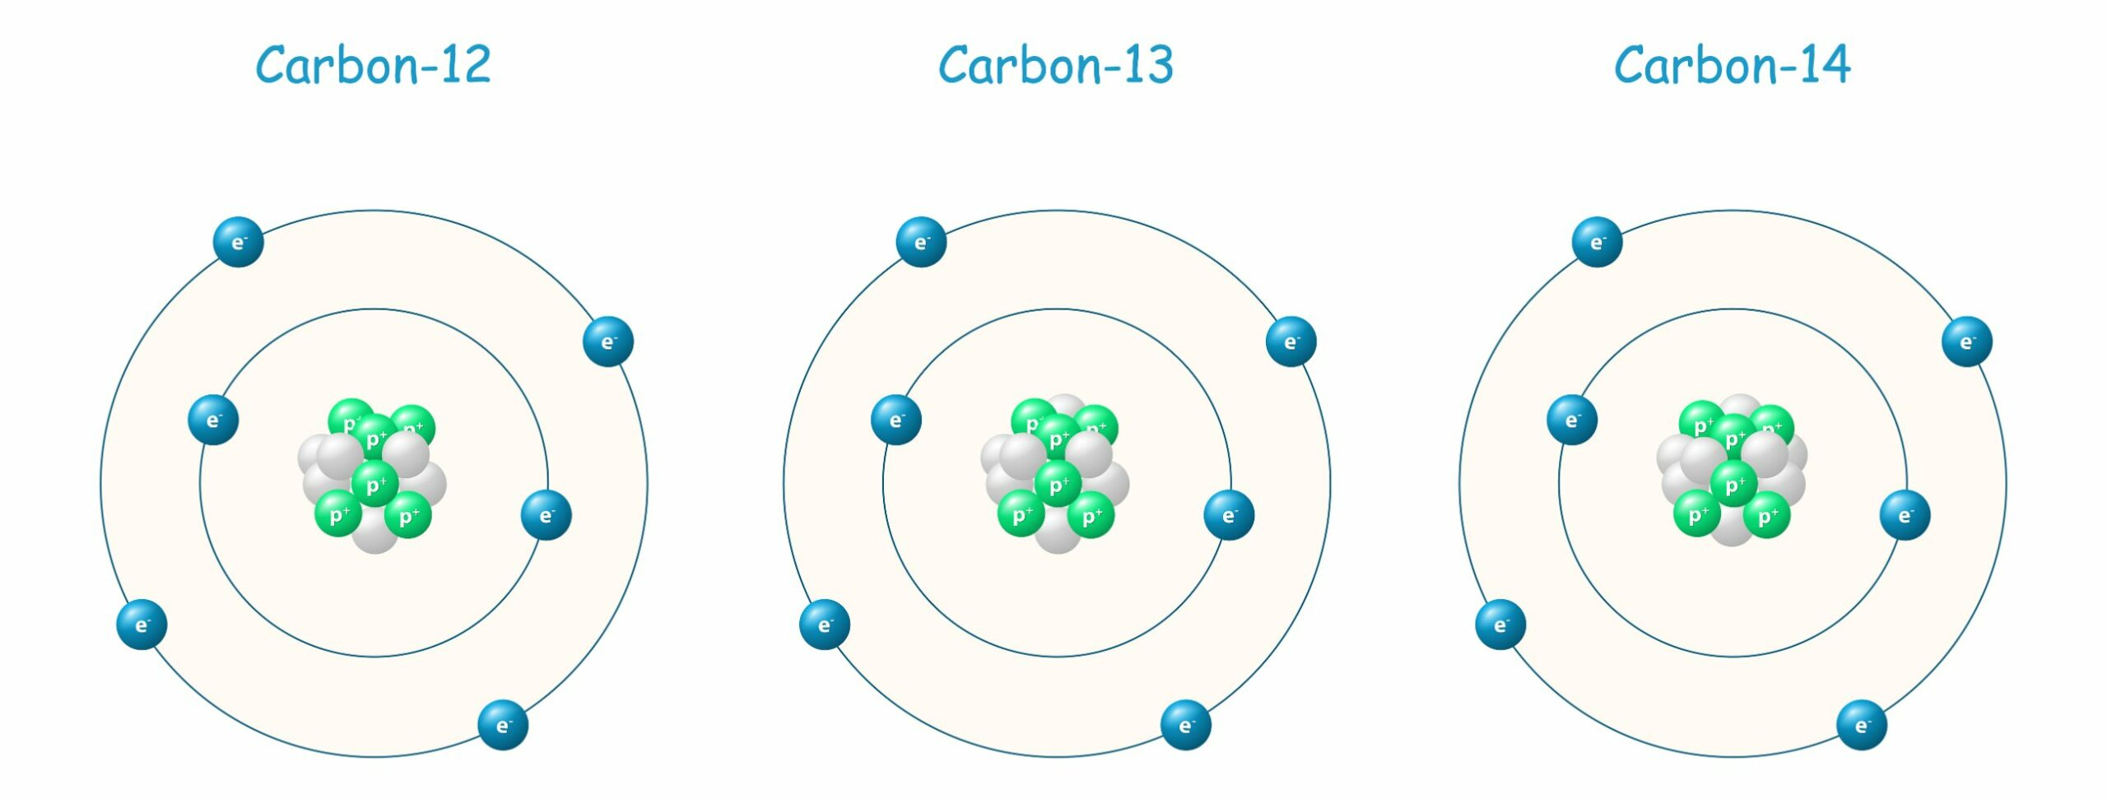

There are 3 isotopes of Carbon

Where does the decimal come from in the atomic mass then?
Isotopic abundance – The percentage of each isotope of an element.
We use the isotopic abundance and mass number of the isotope to determine a weighted average. This is the mass recorded on the periodic table.
Ex. Silicon has three isotopes
Isotope  Mass | Isotopic Abundance ( % )
Si 28 | 92.213
Si 29 | 4.68
Si 30 | 3.09

You Try; Germanium has the following isotopic composition. Calculate the atomic mass of Germanium
Isotope  Mass | Isotopic Abundance ( % )
Ge70 | 20.5
Ge71 | 27.4
Ge73 | 7.8
Ge74 | 36.5
Ge76 | 7.8

