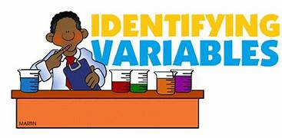
Date: ________________________________

Experimental Variables
All experiments have variables.
These variables will affect how a reaction occurs.

Types of Variables and Examples:
Variable Type | Definition | Example
Dependent
Independent
Controlled
You will need to be able to identify these variables in all upcoming inquiry activities

