Date : __________________________________
Limiting and Excess Reagents
Remember the last time you sat around a campfire with your friends. The plan was to make Smores…...so yummy! Being good planners, you broke up the responsibility and the cost of buying the ingredients.

- You were responsible for providing Graham crackers, and brought a box of 50.
- Nina went to Costco and bought a giant bag of 120 Marshmallows.
- Bishop founds a 3 pack of Hershey bars, each composed of 12 yummy squares of dark chocolate.

If 12 of you went camping, how many Smores can each of you have?
Who is going to be in trouble for not bringing enough supplies?
How many Marshmallows are going to be remaining?

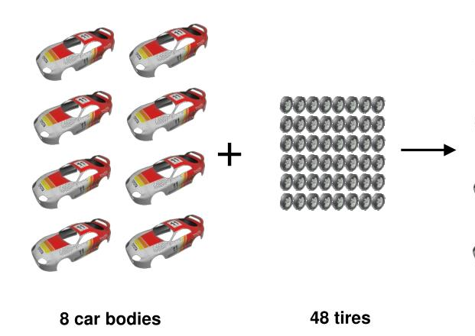
Ex. 2 – How many cars can be built?
What will limit or stop more cars from being built?
What will be in excess and left over after?
Ex. 3 - A flask contains 7 oxygen molecules and 10 hydrogen molecules. What happens when a spark ignites the mixture?
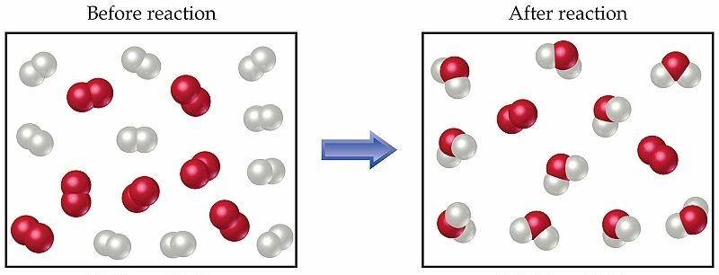

What is the excess reagent? ( What is left over ) ________________________

What is the limiting reagent? ( What has run out ) ________________________

Ex. 4 …..lets bring in some calculations
Determine the amount of titanium produced when 2.80 mol of titanium (IV) chloride reacts with 5.40 mol of magnesium.

Ex. 5 Methanol ( CH₃OH ), can be made using a synthesis reaction involving carbon monoxide and hydrogen. What mass of methanol can be produced from 9.80g of carbon monoxide and 1.30g of hydrogen?

