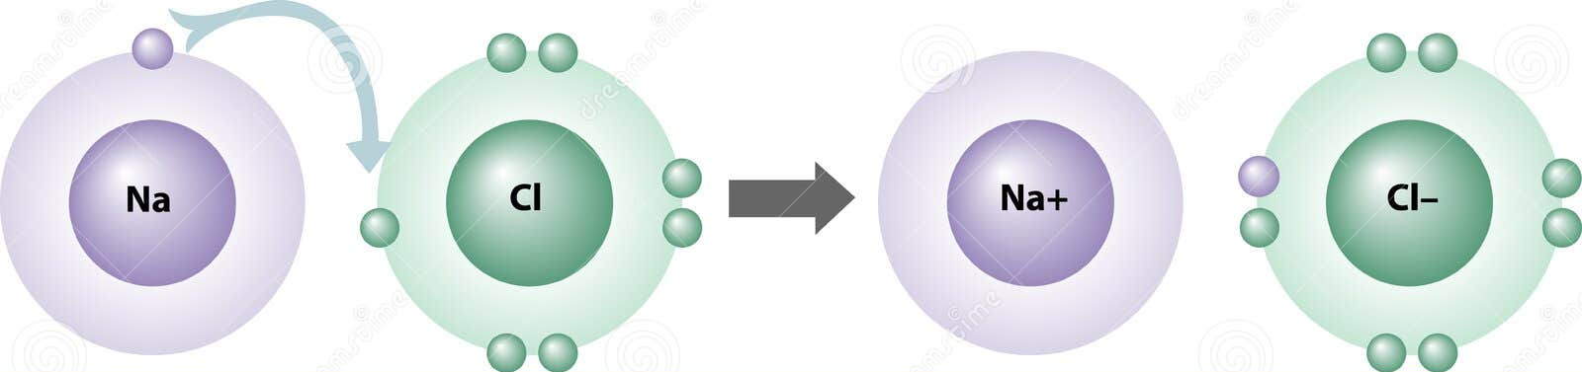
Date: ______________________________

Ionic Compounds

Scientists estimate that that over 10 million different compounds have been identified are more are being synthesized every
day. All compound are held together by ____________________________________.
We can divide the compounds into two main categories based on what they are made of
Composed of
Example

Properties of Ionic Compounds: ( consider salt as a good example )
-

-

-

- Electrolytes -
The formation of Ionic Compounds
You know that neutral atoms will gain or lose electrons to form __________
- If an atom gains electrons it becomes ______________________charged and is called a __________________
- If an atoms loses electrons it becomes _______________________charged and is called an __________________
- Atoms will gain or lose electrons to follow the _____________________________________
Example of ionic compound formation using Lewis Dot Diagrams
Magnesium and chlorine :

Draw Lewis Symbol diagrams to show the formation of bonds within the following ionic compounds. Write the chemical formula for the compound produced.
- Potassium and Chlorine b) Calcium and Chlorine c) calcium and oxygen d) Potassium and oxygen



The structure of Ionic Compounds

